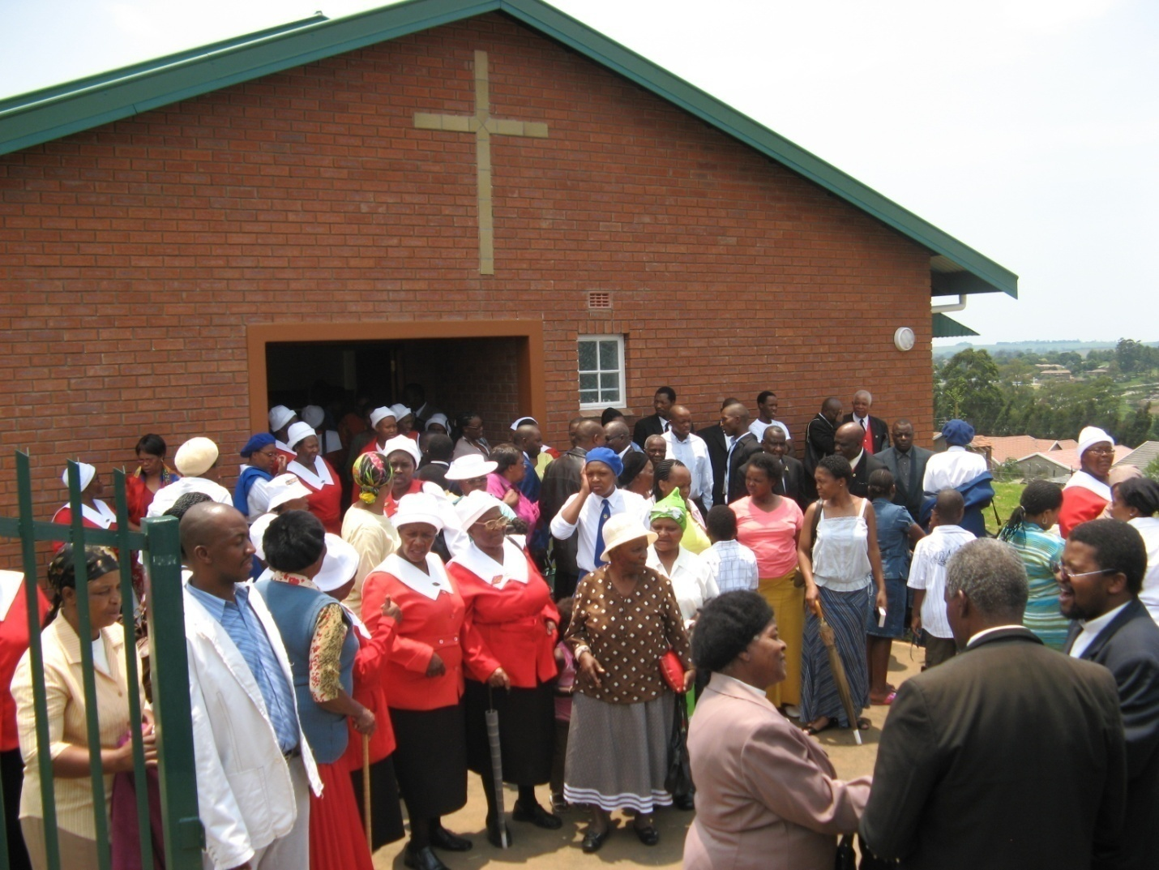
BRENTWOOD METHODIST CHURCH
:
Agent of Healing and Hope for Mpophomeni and Tumbleweed

R. Simangaliso. Kumalo

Table of Contents

Introduction | 4
The profile of Mpophomeni and Tumbleweed | 7
Religion in Mpophomeni | 10
The Ministry of Brentwood Methodist Church | 19
The impact of global transformations on religious communities | 22
Conclusion | 25
 | 27
Bibliography | 29

Introduction

No one can do everything, but everyone can do something. Let not the size of the problem spoils our determination of will. We may not be able to solve world hunger, but we can take a homeless person to lunch. We may not have the power to restore the environment, but we can clean up the mess in our backyards. That makes all the difference.
J. Howard Olds

The aim of this booklet is to provide an illustrated comprehensive report of the work of Brentwood Methodist Church in the communities of Mpophomeni and Tumbleweed since it was founded in 2011. It is a substitute to brief periodical reports that should have been produced in these periods and covers some of the gaps in those reports. My hope is that by reading this booklet our friends may find inspiration to continue supporting our work, others may know about our work and partner with us and those who do not know what we are doing may know. In a booklet of this nature where the focus is on the experiences of a community in a particular context, it is imperative that the nature of the context is made explicit. The struggles of life that people experience as they try to make sense of living within the context of such pain and suffering has had a great impact on the author as a pastor and activist-intellectual in Mpophomeni and Tumbleweed for over a decade. There is no one model or theory that is adequate for us to portray the pain and hope of a community as it struggles for survival. This reminds us as religious activist-intellectuals that we have limitations as Graham Philpott acknowledges:

It is recognition that the researcher and observer is only one part of a greater dynamic of the community’s life, a dynamic which the researcher does not control, but is privileged to participate in and learn from (Philpot 1993:30).

The booklet you are holding is not only of the pain of disease, unemployment, poverty and marginalization under which the people of Mpophomeni and Tumbleweed must strive for survival, but also of their lives as members of a community that is trying to hope for a better future. During the research, I realised that the paradox is that in the mist of death there is life, within poverty there is community, and within pain there is hope. These are the values and ideals that keep these communities going from one day to another. Most importantly these are the unique gifts that are offered by the church to the community. If we are simply overwhelmed by the death and destruction caused by the disease, we ignore the community’s struggle for survival and the hope which they have established within their sphere of life. Writing in the context of North America in his study of immigrant sharecroppers, Robert Coles observes:

Of course their whole lives are marked with the ‘struggle for survival.’…Yet even so, among the great majority of the poor those who live at or just above survival level—and even among the destitute, one can find an impressive feeling of dignity and a vigorous expression of and a joyful taste for life (1969:26).

In the discussion that follows the introduction, information is offered on the demographics and physical conditions under which the people of Mpophomeni and Tumbleweed live. However, this information is not enough to demonstrate the way of being that these people create as they interact, exploit and manipulate their environment to make life possible for themselves. The way of life in it is presented from two perspectives—pain and hope. These two perspectives are integrally linked in Mpophomeni and Tumbleweed, demonstrating two sides of the same reality which interact with each other constantly in this community. They are also manifest in the life, objectives and mission of Brentwood Methodist Church, who ministry is gradually making a modest impact in these communities. The aim of this booklet is to share the work of this community of faith so that you can respond to the call to partner with us in mission. I owe a great deal of gratitude to a number of people, for the completion of this small book. First, to the people of Mpophomeni and Tumbleweed who have embraced my ministry to them from the time when I was a student at the local University? They tolerated my fallibilities and endless blunders as a minister in training. I am also grateful to those who agreed to be interviewed both from the church and outside. I know that the people of Brentwood are grateful for the support they are receiving from the Metropolitan Circuit. Gratitude also goes to all the friends of Brentwood Methodist Church especially our sister church Brentwood United Methodist Church and the Iowa Conference in the US.

Lastly the people of Brentwood Methodist Church themselves are God’s gift to the communities of Tumbleweed and Mpophomeni, I am grateful to each one of them for their support. If I can mention a few of them Mrs R Kumalo who leads the Women’s Manyano, our stewards Mrs Dudu Malinga, Sbu Shangase and Aaron Madlala. Our circuit Superintendents Adrian Roux, Alan Bester, Mike Stone and circuit steward Mr Milton Ncolosi, Zodwa Sikhakhane, Dumi Zuma, Mazwakhe Zakwe Duncan Jili, Mrs Z Ntoyi, Alzinah Mabaso, Kesseth Mkhize, Sabelo Ntoyi, Ayanda Nxumalo, Mandla Vilakazi, and many more others. Amongst our student minister’s one can remembers the Revs Jenny Hillenbrand, Sibongiseni Shabalala and Linda Martins. Brentwood Methodist Church can see far in the future because its stands on the shoulders of these faithful servants of the Methodist Church. Enjoy the book so that you can partner with us in our journey of faithfulness to the one who has called us.

Grace and peace
Rev. Dr. R. Simangaliso Kumalo
Brentwood Methodist Church & UKZN
September 2011.

The Origins of Brentwood Methodist Church

Throughout its history, Brentwood United Methodist Church has emphasized the importance of worship, taught the Christian religion, lifted up the importance of missions, and has offered Christ to all who would give an ear.
The Rev. Dr Joe Pennel

In 2003 the community of Howick Methodist Church some of whom came from Mpophomeni had a vision of starting a Methodist Church in the then developing community of Tumbleweed. They shared this vision with the Rev. Simangaliso Kumalo who at the time was an assistant minister at Howick Methodist Church. Three women who were members of this church namely Kesseth Mkhize, Zandile Ntoyi and Alzinah Mabaso had contributed an amount of money and bought a Church site in Tumbleweed. This was made easy by the fact that the inkosi (chief) of the area Inkosi Selby Makhosonke Mkhize was a member of the Methodist Church, so he helped with the attainment of the church site. Rev Kumalo discussed the matter with the Rev Bill Whitehead who was the Senior Minister and they agreed to support the initiative of building a church at Tumbleweed, which would be an extension of the work at Howick under the Metropolitan Circuit. It also happened that the same year Rev Kumalo would go to the United States of America to continue with his PhD studies at Duke University. It was whilst he was in the US that he was introduced to Brentwood Methodist Church by the Rev Janet Wolf, another Methodist minister. Brentwood Methodist Church, Nashville Tennessee is one of the largest and respected United Methodist Church in the US. In this church Rev Kumalo proposed a partnership between the two churches to the Senior Pastor the Rev Dr Howard Olds who embraced the idea.
After Kumalo came back from the US, Brentwood sent a number of Mission Teams to work in Mpophomeni and Tumbleweed, providing food for the hungry, buying uniforms for school children etc. In 2005 they agreed to the idea of financing a church building at Tumbleweed and sponsoring a minister for a period of 5 years. The Revs Whitehead, Kumalo and some members of Howick Methodist Church played a prominent role in facilitating the building of the church. Brentwood donated a sum of R1.2 million for the building of the new church at Tumbleweed. Most importantly this was to be the first church building in this budging community. Building resumed in mid 2007 and was completed by the end of the same year. The first service was held on Christmass Day 25 December and the Rev Kumalo was the preacher of the day. The first minister the Rev Bongani Mquqo was stationed in this congregation. He labored up to end of 2009. In 2010 the Rev Dr Simangaliso Kumalo was asked to lead the congregation as a part-time, non-itinerary and non-stipendiary minister. He is the current pastor. The Church is growing numerically and it is impacting the community through a number of exciting programmes. It has a pre-school project with sixty children. It has an HIV&AIDS ministry. It regularly holds revivals and mission outreaches where material and spiritual support is given to those in need. Although the church is at its 4th year since it was founded, it has already acquired great respect from the communities and leadership of Mpophomeni and Tumbleweed and the government. In the words of the Provincial Minister of Health Dr Sibongiseni Dlomo;
Oh how we in government wish we can have more churches ready to work and partner with us so that we can improve the lives of our people, through wellness programmes. This is one of the few churches that have invited us to come and see what they are doing and to partner with them in this good course.
Echoing the same sentiments the local municipal councilor Mr. Zuma said that:
It is good to see a church that is getting involved in the activities aimed at improving the standard of living in poor communities like Tumbleweed. I am proud to be associated with Brentwood Methodist Church and also with Tumbleweed.
These above words of encouragement demonstrate the respect with which the church is held in the community. With this kind of support from the community and its leadership it is bound to grow from strength to strength.

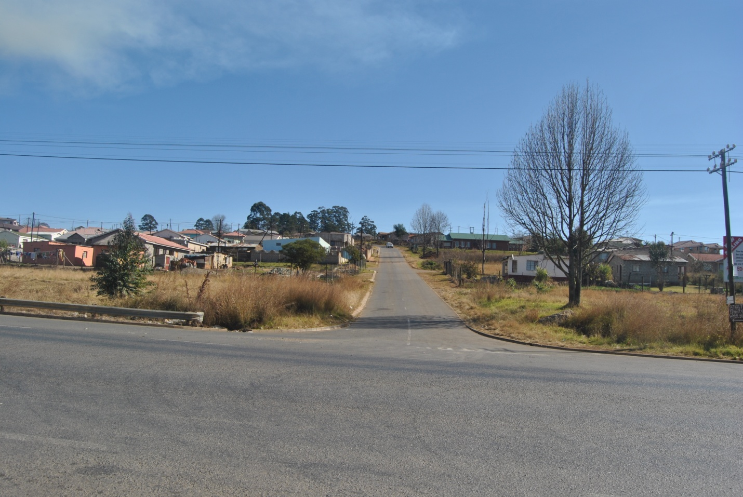
A panoramic view of Tumbleweed. See BMC with green roof.
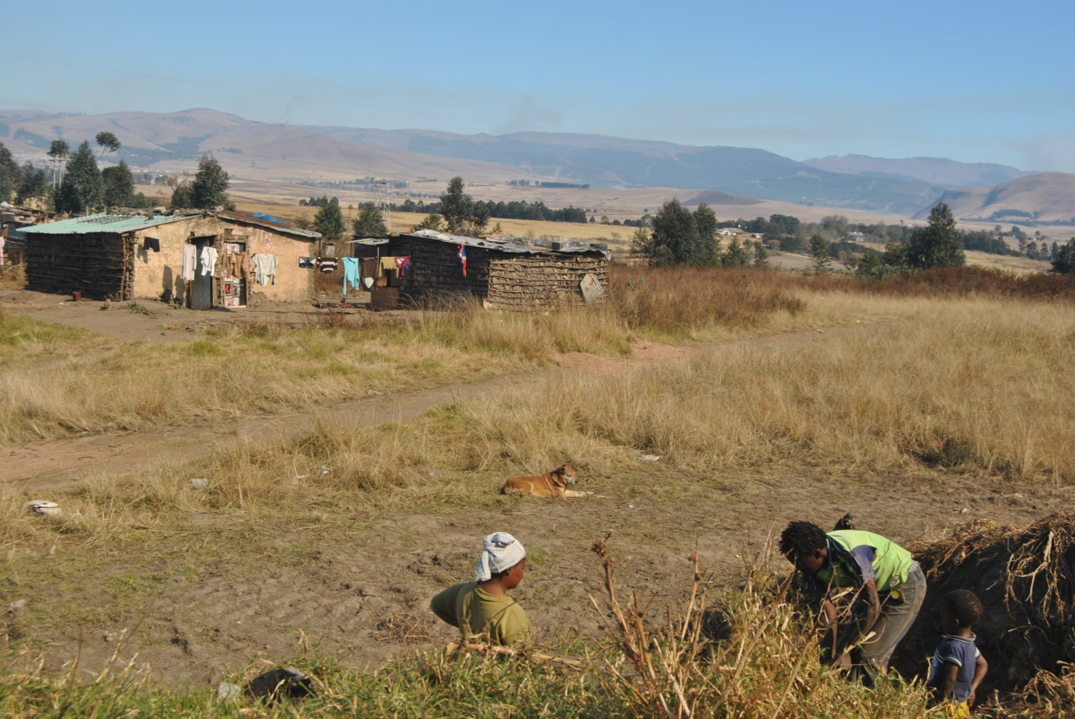
A family digging sand to repair their house.
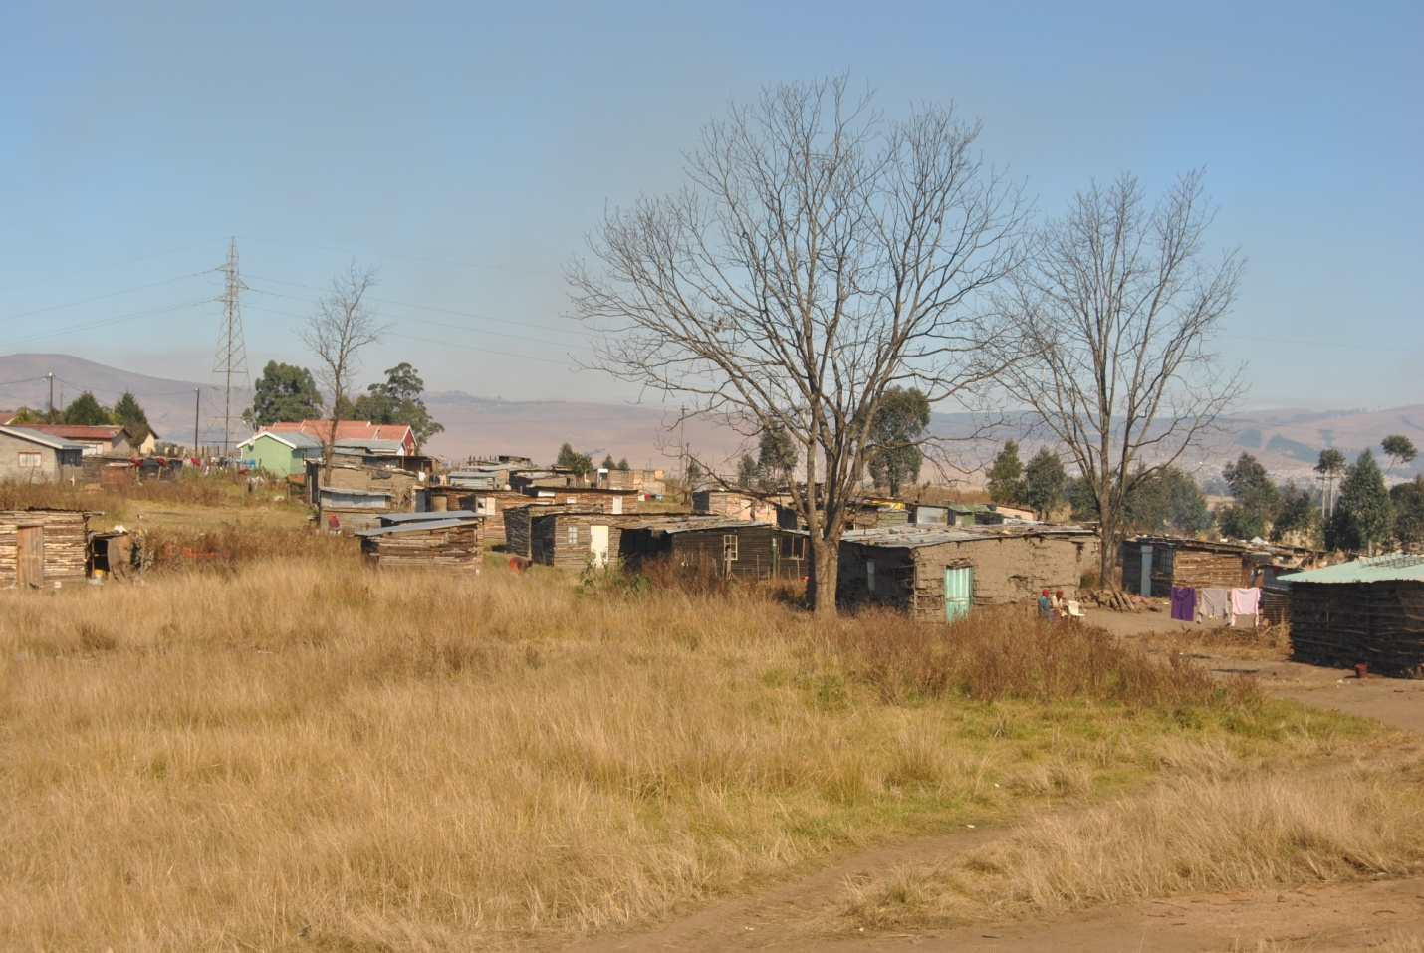
The informal settlement part of Tumbleweed
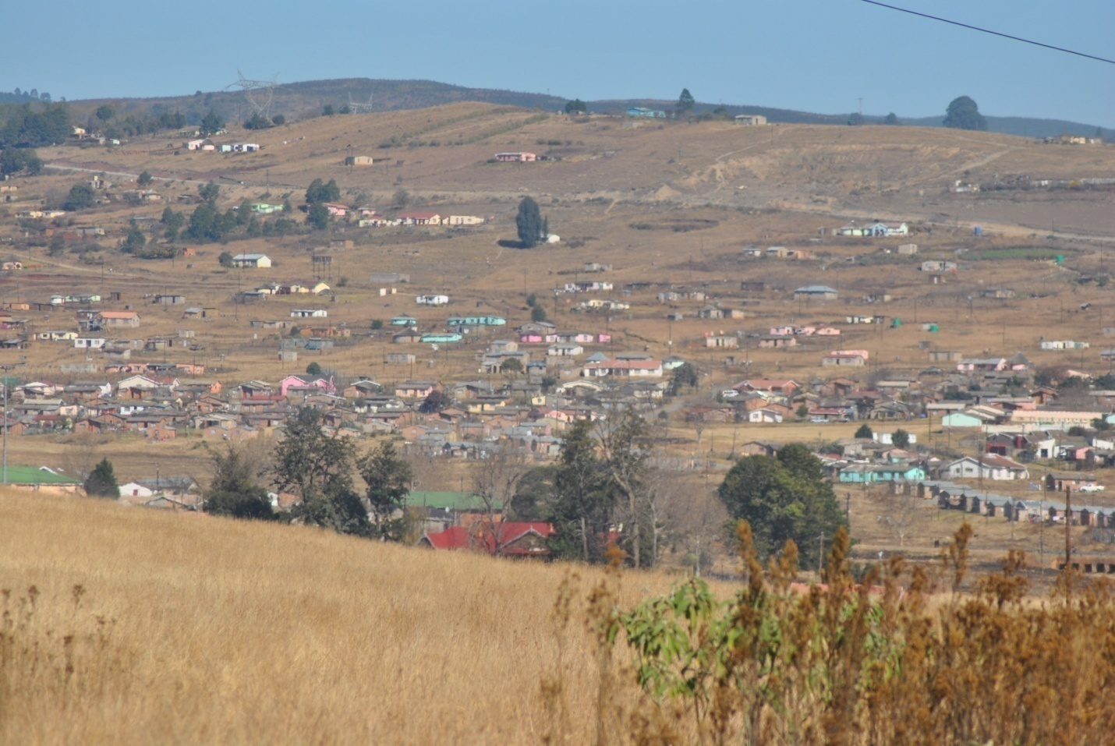

A panoramic view of Mpophomeni

The Profiles of Mpophomeni and Tumbleweed

Any church is located within a particular community and context. Each community has its own unique contextual socio, economic, political, religious and cultural dynamics which it presents to a church that seeks to do mission in its midst. Churches that intend making a lasting impact through mission need to take these dynamics into account. Then they can be sure that they will bring about a lasting transformation to the community. Mpophomeni and Tumbleweed are no exception to this, so we need to explore their profiles so that we understand the challenges faced by Brentwood Methodist Church and the reasons for the approach it is using to minister to these communities.

Geographical location of Mpophomeni and Tumbleweed

Mpophomeni is one of the settlements surrounding the small town of Howick, about thirty kilometres north-west of Pietermaritzburg, the capital city of the province of Kwa-Zulu-Natal in South Africa. The name ‘Mpophomeni’ means waterfall. This has reference to the Howick Falls in the UMngeni River, a well-known tourist spot near to Mpophomeni. The community was founded in 1966 as a result of the Group Areas Act. The Group Areas Act of 1950 carved up the geography of towns and cities, declaring areas either white, coloured, Asian or black. It determined where people of different races could live, work and do business. Mpophomeni is situated about fifteen kilometres west of the town of Howick, isolating its inhabitants and burdening them with the additional cost of travel.

Tumbleweed is an extension of Mpophomeni and was built in the turn of the millennium (year 2000). It is 5 kilometres from Howick and 10 kilometres away from Mpophomeni. It is located between the two. It absorbed people from Mpophomeni and the surrounding villages and rural communities. It is built on a farm that was bought by government from a private owner in order to build low cost (RDP) houses for people migrating from Mpophomeni and rural places to be closer to the city (Howick & Pietermaritzburg) for economic reasons.

Howick is very important for Mpophomeni, even though it is a rather small country town, because it is the nearest commercial centre. It has only two main streets but provides shopping facilities, three banks, a post office, municipal offices and other facilities. Howick is also important because this is where most people from Mpophomeni work. Rural communities such as kaShifu, Hhaza, Emashingweni and Mafakathini, surround Mpophomeni. Unlike Mpophomeni and kaShifu, the other communities do not have electricity, potable water and other basic services. People are thus constantly migrating to Mpophomeni with the hope of finding a better life and employment opportunities. Of most significance, Mpophomeni is located in the heartland of KwaZulu-Natal, a province known for having the highest HIV and AIDS infection rates, thus making it a place of constant pain and suffering. At the same time, however, it is a community full of hope.

Origins of Mpophomeni and Tumbleweed

The area now called Mpophomeni previously belonged to the Lund family who operated a farm from the 1890s. The farm was declared a ‘black spot’ by the apartheid regime, which meant it was earmarked for black people who were removed from areas close to towns reserved for white inhabitants. It was used to accommodate workers who provided labour for the farms in and around Howick. The Lund’s were ordered to move from the land in 1963 in order to give way to black people who were removed by the government from the mixed communities of Zenzele and kaGeorge on the fringes of the town of Howick. Mr Guy Lund refused to move from his farm and eventually committed suicide rather than be forcefully evicted by the government

The first inhabitants of the new township were labourers for the construction of Midmar Dam, who were removed there in 1966. The first permanent homes for the new inhabitants were built in 1968. More were constructed in 1972. Even though the township was ready for occupation from 1968, most of the residents (67.7%) moved in after 1978 when the government intensified its forced removal activities in Howick. The community of Mpophomeni is therefore not a natural one, but a creation of the zealously applied unjust laws of the apartheid regime and its racist planners and social architects. Today, Mpophomeni, as with many other poor townships in South Africa, stands as a reminder of the baneful legacy of apartheid that left many black communities poor and vulnerable to epidemics such as HIV and AIDS.

Tumbleweed was developed in early 1999 when the government responded to the increasing need for more houses for people who were moving from the rural areas and surrounding townships to be closer to the town of Howick and Pietermaritzburg. It bought the Tumbleweed farm and with the involvement of Chief Selby Mkhize began to develop a township. Land was given to people from KwaHHaza, Mafakathini, Sweetwaters, Mpophomeni and Cedara to build their homes. In 2011 there are over a thousand homes in Tumbleweed, one school, two churches buildings and two pre-school.

The Population of Mpophomeni and Tumbleweed

The 1996 National Population Census reports the population of Mpophomeni to number approximately 34,000 (uMngeni Municipality 2005). Tumbleweed has a population of about 5 000 people. Together these two communities have a population of over 40 000 people. While the great majority of people in Mpophomeni and Tumbleweed are Zulu speaking and Afrikaans, they might be described as integrated communities. There are a growing number of other ethic groups such as Xhosas, Sothos and immigrants from other countries such as Mozambique, Swaziland and Zimbabwe. According to the National Census records, in the period 1996-2001 the population of Mpophomeni grew by a total of 3,187 people (uMngeni Municipality n.d.). More than 25% of the population are young people and they are the most affected when it comes to HIV/AIDS. According to the University of KwaZulu-Natal research fellow, Christopher Desmond, in early 2001 there were close to 100,000 child orphans fifteen years and younger living in KwaZulu-Natal alone (The Natal Witness, March 21, 2001). Mpophomeni was the first community in KwaZulu-Natal where child-headed families resulting from HIV and AIDS were discovered as early as 1997. In 2001, there were 43 child-headed families in Mpophomeni (uMngeni Municipality n.d.). Tumbleweed has also added to the number of child-headed families.

Housing and Services

The conditions under which people have to live in Mpophomeni and Tumbleweed create a constant struggle for survival. Although the meeting of basic needs has improved, there are still pockets of these communities where they are not yet met. Housing, for example, has always been inadequate to accommodate the number of people that moved into the community. Most houses (72.7%) consist of four rooms (kitchen, lounge and two bedrooms). Recently, a significant number of one-roomed ‘RDP houses’ have been built by the government through its housing programme aimed at alleviating the housing problem in the country. The older homes were made of brick with asbestos roofs; the new RDP houses are made of cinder block and corrugated iron. To date, the total number of houses in Mpophomeni and Tumbleweed is about 25,000.

Conversations with the residents of Mpophomeni and Tumbleweed indicate that most people intend improving their homes, generally adding more rooms to their four or one-roomed government subsidised houses. Equally important, is the feeling of residents that by developing their property, they will have an investment to pass on to their children. Brick houses suggest that an owner is formally employed and enjoys access to a housing benefit; but the fact remains that due to poverty and joblessness, only a small fraction of homes in the community are being upgraded (Ndlovu 2005). However in Tumbleweed you can see a number of beautiful houses that are gradually developing as people improve the smaller RD houses.

There are also a few privately built houses that belong to those who hold better jobs, either in government or private industry. With the growth in housing there has been a commensurate increase in sexual activity within the community. The government required that every young person of twenty-five years of age register for a house. More young people registered, acquired their houses and moved out of their parent’s homes to become independent, even though a majority of them did not have work. To earn a living, most engage in sexual relationships with older working partners, thereby making them more vulnerable to being infected with the HI-virus. The RDP houses have also exacerbated the movement of young people from their parent’s homes to their own houses. As a result a section of Mpophomeni is known as “Ebumnandini” (nice place) because its residents are young people who have moved to their own RDP houses to enjoy freedom from their parents.

Both Mpophomeni and Tumbleweed have informal settlements or squatter settlements. These are sections that have developed without proper planning by the municipality. Houses here are built out of any material ranging from wood, plastic, corrugated iron and grass to cardboard boxes. There are no roads, but just gravel pathways. There is neither running water nor electricity in this section of Mpophomeni and Tumbleweed. Residents of the informal settlement section are at the lowest level of the social, political and economic stratification of Mpophomeni. This makes them more vulnerable to suffering and disease such as HIV and AIDS.

In summary, one can conclude that Mpophomeni and Tumbleweed have four social classes: the upper class comprised of those who are professionals such as nurses, teachers and clerks, recognised by their subsidised brick and tile houses at the entrance to both communities; the lower middle class, who are artisans and owners of small businesses and who stay in the old four-roomed municipal houses in the main section of the communities; the lower class, a majority of whom are young people who live in the government subsidised one roomed houses with water and electricity. Finally, there are the informal settlement dwellers. These can be described as the lower class, a majority of whom have no income whatsoever nor properly built houses nor services. All the residents are vulnerable to HIV and AIDS although with varying degrees of vulnerability, with the poorest being the most vulnerable.

Infrastructure

Only the main roads are tarred, the rest remain as dirt or gravel roads. Likewise, only the main streets are lit by streetlights. The lights, however, are very sparse and weak increasing the risk of crime and rape of women in the community. Although more houses have been built in both Mpophomeni and Tumbleweed, these townships remain largely underdeveloped, with poor drainage and intermittent servicing of its roads. Although there are state schools in Mpophomeni, these are overcrowded, making it difficult for teachers to provide adequate education, especially sex education. Tumbleweed has only one School (known as Cosmos Primary & High School) which is still being developed. Tumbleweed has only two pre-school, one run by a charismatic congregation and another by Brentwood Methodist Church. There is only one clinic which serves communities, offering health education and treatment. With regard to HIV, the CDC health project has been an important resource together with the HIV and AIDS awareness project of Zenzeleni. Brentwood Methodist Church also runs a care-giving centre.

Economic Circumstances

B. T. R. Sarmcol, a British-based rubber producer, used to be the main industry in the Howick region, and was responsible for the livelihood of many of the residents of Mpophomeni. It had a total of 1375 employees. Some 39.5% of the total workforce of Sarmcol came from Mpophomeni (Bonnin 1987:193). From as early as 1980 the company had embarked on a rationalization exercise which was aimed at reducing its workforce. The workers were concerned about the loss of their jobs. In May 1985, a bitter and protracted strike took place due to dissatisfaction over poor working conditions and low wages. The strike resulted in the dismissal of 975 workers, a huge majority of whom were from Mpophomeni and were bread-winners in their homes. The dismissal of the BTR Sarmcol workers left a bad legacy in Mpophomeni. I would like to turn to looking at it now.

Social effects
On the 23 -24th June 1985 violence broke out in Mpophomeni between those who were on strike and had lost their jobs and those who had been employed by the company as “scab labourers” popularly referred to as “Amagundwane” rats. Those who had been retrenched were referred to as “Amakati” Cats. This divided the community into two groups those who had been dismissed “amakati” by the company and those who had been newly employed “amagundwane”. The two groups went to war with each other. A number of people lost their lives in the war that broke out and the community was totally destabilized. One of the victims was a 4 year old little girl Nokulunga Gumede who was run over by the police caper during the violence. A result a number of children lost their parents in that war. Schools were closed for a long period and as a result some children (who are now adults) were forced out of school and never went back for their education. The culture of violence has never left the community; it has manifested itself through rampant gangsterism which is ripe in the community.

Economic effects
As shown in the discussion above Sarmcol was the major employer in Mpophomeni. So when people were dismissed the community was left without an important source of income. As people lost their income some lost all they had in the violence that ensued. Houses were burned down. Some families have never really recovered from the loss of property and reliable income.

Due to poor education, most residents of Mpophomeni and Tumbleweed are manual labourers. There are very few opportunities for post-high school skills training, and it is very rare for young people from these communities to gain access to institutions of tertiary education and training, although the situation is improving. The lack of basic services ensures that the cycle of poverty continues, and limited educational opportunities inevitably lead to a high unemployment rate. It is clear that these communities’ economic survival largely depends on mostly unskilled, manual labour. According to the 2001 Census, the rate of unemployment in Mpophomeni and Tumbleweed was 60% (uMngeni Municipality n.d.). While formal unemployment is high, some residents are employed, doing a variety of informal or casual jobs, such as gardening, painting, bricklaying, baby-sitting, driving, washing and general housekeeping chores in the Howick and Pietermaritzburg area. When a household has no form of employment, neighbours often offer support. One interviewee stated that there is much good neighbourliness that provides support to those in need. These patterns are typical of low-income communities, including poor townships. However the reality of poverty and the struggle for survival puts people at the risk of getting infected with HIV as they deal with the pain of struggling to survive.

Religious Life: Sources of Hope

Mpophomeni and Tumbleweed are very religious communities, with Christianity clearly dominant. Therefore it is important that when studying the impact of HIV and poverty, which are a health challenge, one also alludes to the religious life of the community. Religion and other aspects of life complement each other in forming the lives of traditional communities like Mpophomeni and Tumbleweed. The observation of Allison Howell in respect of the Kasena people of Ghana applies also to Mpophomeni:

The religious and the irreligious are so closely interwoven that at times it is difficult to distinguish between the two. To approach life and problems in the physical sphere means relating to what is perceived as spiritual; to approach spiritual matters means also to deal with the practical realities of life (1997:95).

There are many Christian churches here ranging from Mainline, Pentecostal, Charismatic, through to African Independent Churches (AICs). Beside churches there are also sects such as Shembe and Amabhidiya. There also other religions such as Islam, Hinduism and African Traditional Religion (ATR). ATR is also in evidence with inyangas (herbalists) and sangomas (diviners). Brentwood Methodist Church is one of the three Methodist Churches found in these communities. There is intense competition for adherents between these different religious groupings. As the vast majority of the population in Mpophomeni and Tumbleweed are religious, Sundays are marked by the movement of people in different directions, many in their colourful church uniforms, with Bibles clutched in their hands, attending worship in the more than 100 churches scattered throughout the community. Some church members do home visitation and provide home prayer support to church members who are sick. Members of BMC are also visible in their red and white uniforms.

The majority of people in Mpophomeni profess to be Christian, but many also mix their faith with African traditional beliefs and their religious practice with traditional African rituals—praying to their ancestors and consulting sangomas when they are sick or in trouble. A common response of the traditional teachers and prophets to the HIV and AIDS pandemic is to confirm people’s suspicions that they have been bewitched thus evading the reality of HIV and AIDS and the stigma that goes with it. When I asked one interviewee why is it that in spite of their poverty, suffering and pain people in Mpophomeni remain so religious, he answered?

It is my hope mfundisi that religion gives us hope to continue with life. In spite of what is going on in the present there is hope for the future. It is through religion that we meet the God of the future and we get hope that we must continue living for things will be better in future (Mabaso 2005).

Giving hope is at the heart of Brentwood’s ministry to these communities, for without it many people would have given up and lost their lives because of the amount of poverty and suffering prevalent here.

Violence and War

Three key background features underlying life at Mpophomeni today are: decades of oppression under apartheid, a decade of violence and war and a decade of living and enduring the devastations of poverty and HIV and AIDS. In this sub-topic we look at the violence and war that affected the community in the early 1980s and how it created fertile ground for HIV and AIDS and poverty. Mpophomeni is one of the many communities that were ravaged by violence in 1985 as the oppressed people sought to respond to the structural and institutional violence of the state. The violence was sparked by the firing of the striking workers of B. T. R. Sarmcol, a majority of whom came from Mpophomeni, an ANC dominated area. The company employed casual workers from surrounding communities such as Mafakathini and kaHhaza, which were Inkatha Freedom Party (IFP) dominated areas. This led to a fight for jobs and also for political power. There was much bloodshed and many homes were destroyed, usually by burning. The security forces did not help the situation because they were perceived to be taking sides with the IFP, a perception later shown to be correct.

An outcome of this war was the intensification of the general level of violence within the community. This is evidenced by the frequency of rapes, assaults, murders and robbery. Although the community has been working hard at healing and reconciliation, especially through the Zenzeleni Community Centre, the wounds will take time to heal. The community is still hurting and this hurt can be seen through the many incidents of abuse against women and children. This puts women and children at high risk of HIV infections because they are living in a violent community.

Factors Contributing to the Spread of HIV&AIDS and Poverty in Mpophomeni and Tumbleweed

There are at least four major factors that contribute to the spread of HIV and AIDS in Mpophomeni and Tumbleweed. The first of these is the process of urbanisation. There is a significant movement of population from neighbouring rural areas to these two communities and Tumbleweed. People move to Mpophomeni and Tumbleweed in order to be in closer proximity to towns such as Howick and Pietermaritzburg, where they can search for employment. This movement of the population greatly increases the transmission of the virus from other parts of the province to Mpophomeni and Tumbleweed.

Second, cultural factors include ubusoka, a belief in the freedom of adult males to have multiple sexual partners. This belief is expressed in the idiom indoda ayihlafuni ngomhlati owodwa, which can be translated as “a man cannot be satisfied by one woman.” A proverb such as this suggests that there are no limits or boundaries as to how many sexual partners a man may have. This belief stems from the patriarchy that is imbedded in Zulu culture. Linked to this is the belief that at a particular age, normally around thirty years, a man or woman should have a child, even if they are not married. If they do not then society views them as having a serious problem—a man is said to be isishimani, (one who is not liked by women), and a women is labelled as inyumba, (barren), which is an insult in Zulu culture. Therefore to avoid these labels and their accompanying stigma, young people engage in unprotected sex.
Third, gender inequality is another factor that causes HIV. Women are more vulnerable to HIV, among other reasons, because they live in a very patriarchal community. Most of the time women have no voice in relationships especially when it comes to matters relating to sex. Men impose themselves on women and sometime refuse to use protection and women succumb to this because they were taught to respect their men. In Zulu culture, boy-children are raised differently from girl-children. They are taught that they are strong and powerful and have to provide for their wives and children who are their subordinates. Girl-children on the other hand, are encouraged to adopt a weaker, but caring and nurturing role and to be subservient to their husbands. These roles are internalised and shape the way people behave in their sexual relationships.
Fourth, poverty contributes to the spread of the disease especially as it affects women. The link between poverty and HIV infection, which is now widely acknowledged, first came to prominence through President Mbeki, whose observation was heavily criticised at first. Women, as noted above, are particularly vulnerable to HIV infection due to poverty. They often lack job skills and access to income generating resources. As a result, they depend on men who are often reluctant to use protection and force women to have unprotected sex with them. Furthermore, some women want to have children, both for the reason given above and also in order to access the child grant made available by government. Therefore they have unprotected sex, thus facing the risk of becoming infected. The largest number of new infections is among schoolgirls between ages of thirteen and nineteen years, many of whom are intimate with older men in the hope of getting money, because they are poor

The Impact of HIV and AIDS on Mpophomeni and Tumbleweed

About 49% of the people of Mpophomeni and Tumbleweed are HIV+. People started taking serious notice of the disease in 1997, but by 2003/4 it had become a major concern. About 70% of people who go to the clinic have HIV-related complications. This estimate is confirmed by the statistics at Grey’s and Edendale hospitals, which are large regional hospitals serving the people referred by the clinic in Mpophomeni. About 30% of pregnant women are HIV+ and of those who are HIV+ 40% are schoolgirls aged between thirteen and eighteen years. Many of these are intimate with older people who are working, and these relationships almost always have to do with money.
At the Wellness Centre at least five people per day are attended to. There is only one clinic in the community assisted by the Wellness Centre that offers Voluntary Counselling and Testing (VCT). Anti-retroviral drugs (ARVs) are distributed in Mpophomeni and Tumbleweed. Not helping the situation is the fact that there is no doctor in the local clinic. The community obtains ARVs in Pietermaritzburg, while the clinic in Howick, acting as a branch for hospitals in Pietermaritzburg, distributes them. Some people already undergoing ARV treatment can get their supplies from the Howick Communicable Diseases Clinic (CDC). There are only two local HIV testing centres—the Howick CDC and the Wellness Centre which is run by the uMngeni AIDS Centre with the support of the Church of the Ascension, Anglican Church of Southern Africa, Hilton.
A hopeful, although still tragic indication, is that in 2003 and early 2004 there was an average of seven funerals every weekend, but by mid 2005 the number had decreased to an average of four funerals every weekend. This could be as a result of the positive effect of ARVs. On the negative side, the rate of re-infection has risen from 3% in 2003 to 5% in 2005. Sadly, it seems that the knowledge people have about HIV and AIDS does not translate easily into behaviour change. Those taking ARVs are infecting others with a form of the virus that seems resistant to treatment. According to the clinic staff the resistance to medication seems to have risen by about one third. The phenomenon of AIDS orphans was noted in 1997 as a major, growing problem in KwaZulu-Natal. Clearly this is a complex social problem that has the potential for great negative impact in years to come. The problem is taking on serious proportions in Mpophomeni and, at the time of writing, there are about forty-three known child headed families in the township and the problem is growing.

Stigma

The level of stigma associated with HIV and AIDS seems to be decreasing, though slowly, and there is still a long way to go. In an interview one of the caregivers who works for Zenzeleni said: “I so wish that the stigma was decreasing and people encouraged each other to go for testing and those who prove to be HIV+ were getting support from the community, but that is not so” (Ntoyi 2005). Some people claim that there is no stigma at Mpophomeni and Tumbleweed. They attribute this to the vigorous HIV and AIDS awareness campaign and education drives. People indeed go in their numbers for testing, supported by family members and friends. There are, however, many who still feel that they would rather not reveal their status, for fear of subtle stigmatisation and discrimination. Significantly, people do not talk easily about HIV and AIDS, or ingculazi, but rather refer to it as lesifo esibulala ingane zethu translated as “the disease that is killing our children” (Ngubane 2005). If there is no stigma, why are they afraid to name it? It seems that, although people do not go around harassing those who are infected and affected by this disease, there is still a general sense of fear and social disadvantage related to it.
When people talk of HIV they do so in generalised terms, never on a personal level. Discussions about people who have the disease are held in hushed tones except, perhaps, within the family. Therefore the assumption that there is no stigma is contestable. This is exacerbated by the fact that in Zulu culture shame is feared and never allowed. You never say anything that might lead to another person feeling ashamed of themselves. Even if the discussion is intended to help the other person, a very careful way is found of expressing things without putting the person on the spot. This has led to people not talking openly about the disease because it is still understood as shame.

The ministry of Brentwood Methodist Church in these communities

I have observed elsewhere that life in many communities is bustling and the church is in the midst of this joy. It is a space where people express the paradox of pain and hope at the same time. In respect of Ivory Park, an informal settlement in Johannesburg, I observed that:

In the evenings there are church services that can be heard throughout the community, and there are also some music centres which cheer the young people (Kumalo 2003:67).

The same can be said of Mpophomeni and Tumbleweed. The Church is a place of community, catharsis and hope.

The churches, as would be expected, provide pastoral care and visitations to the sick, provide support for their families especially the children and conduct the funerals of most of those who die from AIDS-related diseases. Brentwood has organised support groups which visit people and pray for them. The problem is that even in those prayers there is a conspicuous silence about the disease—it is never named. Sermons and hymns seldom say anything direct about HIV and AIDS. Opportunities for relating God to HIV and AIDS are not availed by the organisations I visited. Ingculazi, as the disease is referred to in Zulu, is not named during prayers or sermons, but usually people talk indirectly of the disease that is killing us and our children. This does not mean that the people of Mpophomeni and Tumbleweed do not have a theology of HIV and AIDS; I believe that they have it. It is only that they are not sure of it and also lack the language to articulate it. There is lack of both courage and theological language to speak about the disease. A good example of a typical response occurred in my congregation. A member lost her husband to AIDS. Two years later she became sick, but refused to accept it. Instead, she blamed her mother in-law for bewitching her. She stubbornly resisted my attempts to reconcile her with her mother-in-law until she died. Even the concerted attempts of the women of the church to speak to her as they visited her, offering their prayers and support, did not get her to accept her condition. She finally died in denial.

On the surface, there seems to be a distinct theological and pastoral silence as far as this disease is concerned. However when one listens to the conversations, prayers, sermons and songs of the people during funerals and pastoral visitations one realises that there is indeed a theology of HIV and AIDS in that people hold. The problem is that it is not yet well articulated because people are not confident of it. How is this to be accounted for? One reason is that in most poor townships such as in Mpophomeni and Tumbleweed, there is a preponderance of African Initiated Churches (AICs) led by pastors who are untrained theologically. As a result, they find it difficult to interpret Scripture in this new context, or to understand the pandemic in the light of scripture. Most pastors of mainline churches who serve such communities, and who are likely to be theologically literate, do not reside in the community, they come once a month or a quarter to give communion. Brentwood Methodist Church is the only church that has a pastor with an extensive theological education and is available to the congregation on weekly basis. Most pastors treat their congregations in Mpophomeni and Tumbleweed as out-stations, visiting them once a quarter. They may have a more sophisticated theology than their AIC counterparts, but they are not always present to engage a community grappling with the pain caused by HIV. Thus there is a great vacuum for theological reflection in Mpophomeni and Tumbleweed that can uncover the theological assumptions of the people with regard to the pandemic.

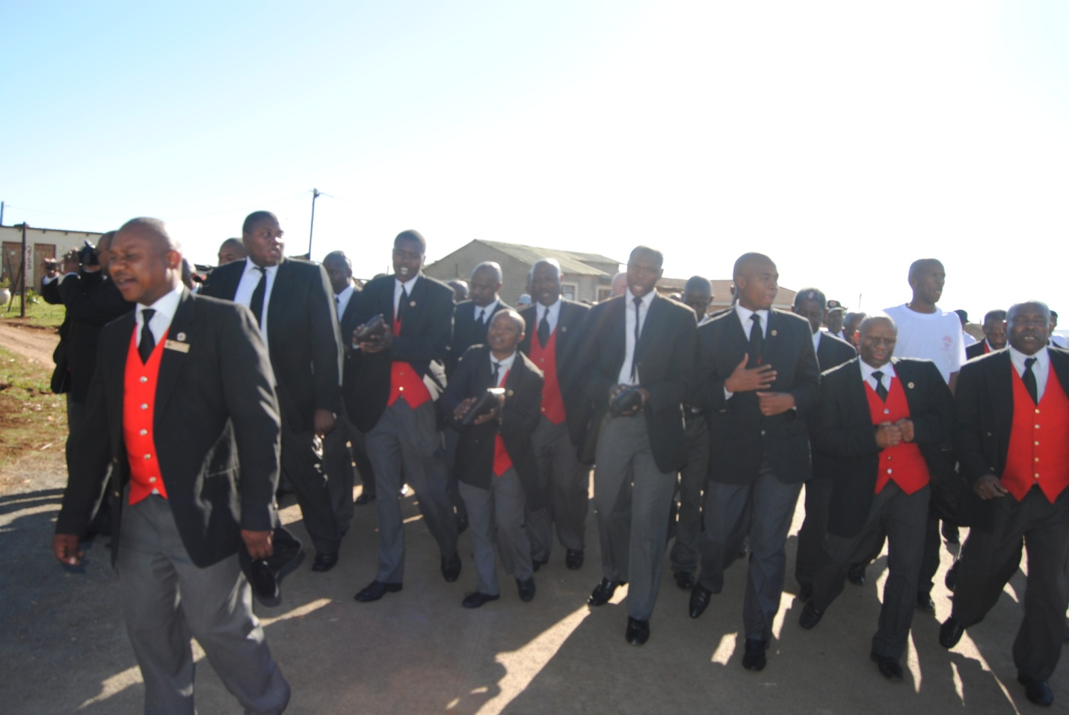
YMG members singing and preaching the word of life in the streets of Tumbleweed
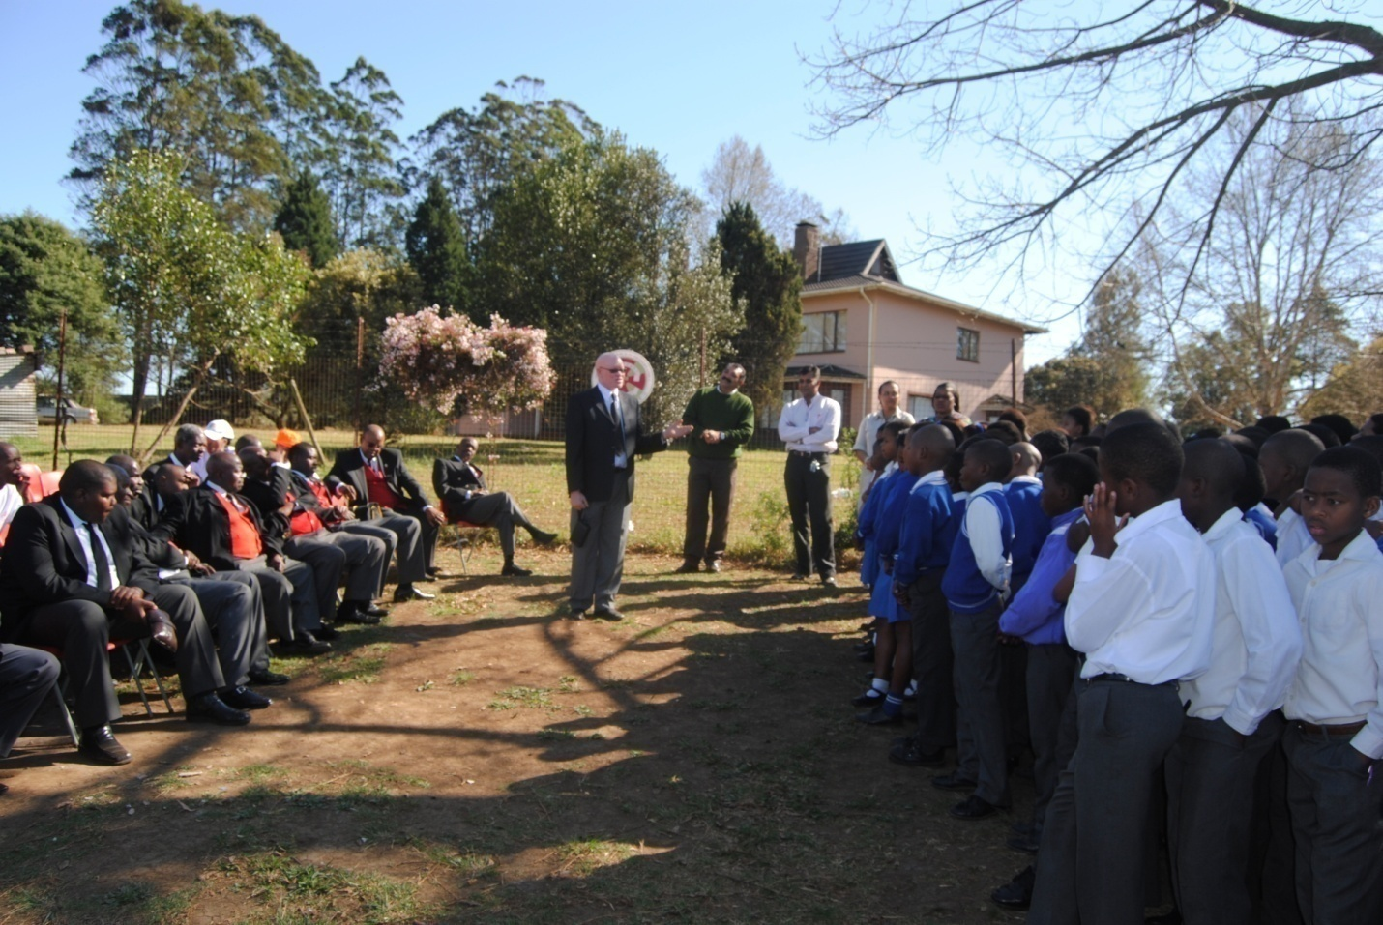
YMG members visit Cosmo Primary School and motivate the students

A Community of Hope: The Zenzeleni Community Centre

Brentwood Methodist Church has been working and would like to strengthen its partnership with the Zenzeleni Community Centre, which facilitates development throughout the community of Mpophomeni and is one of the most important local initiatives. The founding vision was that of a self-help centre and sponsorship was obtained from foreign governments such as France and Belgium. It serves as a springboard for community projects that seek to address the vast needs of the community. It was founded in 1993 just before the end of the political violence that subsided during the same year. The establishment of this community centre in Mpophomeni was the result of long negotiations between the religious leaders and the main political parties that were involved in the conflict—the UDF and the IFP. Religious leaders from outside and within Mpophomeni, some linked to the University of KwaZulu-Natal (UKZN), worked to bring about reconciliation. These mediators advised the leaders of Mpophomeni on how to transform the situation by transferring their attention and energy from war to development. Their efforts express and embody the familiar words of the papal encyclical Populorum Progressio, that, “development is the new name for peace.” The aim of the Zenzeleni Community Centre was to help people rebuild their lives with a focus on independence. Young men from Mpophomeni were sent for training in Pietermaritzburg to acquire various skills such as bricklaying and plumbing. They used their newly acquired skills in the building of the Centre.
The Zenzeleni Community Centre is run by an elected committee and most of its trustees are members of the local community. It houses facilities such as computers and sewing machines that are used on a regular basis by members of the community. It is also presently the base for the Zulu Mpophomeni Tourism Centre, which facilitates the opportunity to visit Mpophomeni and experience staying with a local family, eating traditional African food, watching Zulu dancing and visiting a sangoma.
The Centre was also intended to act as an umbrella body for other community building projects. The establishment and growth of such projects has done much to bring hope to the people of Mpophomeni. Some of these are: Ethembeni (‘Place of Hope’); the Wellness Centre; Friends for Life (providing home visits for the terminally ill); a paralegal office, which focuses on issues of rape and gender; the Brick campaign (led by Zenzeleni and planning to build a Community Centre housing different self-empowerment projects); the Poverty Alleviation Programme; agricultural self-help projects sponsored by Zenzeleni; the uMngeni AIDS Centre; Sakhisizwe and Thuthukani (Self-help projects for pensioners); Isibani; Ilanga Support Group; Mpophomeni Computer Centre; Young Designers School of Fashion and Fabrics; Masibambaneni Support Group, Sekusile CBO; and the Almighty Light of Unity (specialising in spiritual healing). There are also plans for a rehabilitation centre, a museum and other tourist attractions.
In the midst of poverty, pain and suffering Mpophomeni is a community full of life, activity and hope. Despite the fact that community members have to compete for scarce resources, people are not allowed to undermine one another’s chances of survival. There is a deep-rooted sense of unity and a quest for the common good for all people. There is the hope of transcending the experience of devastation caused by poverty, unemployment and HIV and AIDS. The community survives through its prayers, religious practices, traditional customs and their various related responsibilities. It is led by younger people who occupy positions such as councillors, chairpersons of community projects and programmes, leading community initiatives such as Zenzeleni and tourism. These entrepreneurial young people are highly regarded by the community and are often proudly referred to as abantwana bethu (our children). The young people themselves have not lost respect for the elderly. They draw on their wisdom and often organise community celebrations and prayers where they invite the elders of the community to preside over the proceedings and recognise their contribution to the life of the community. This sense of mutual respect arises out of ubuntu, that special quality of humanness that is expressed in the Zulu idiom umuntu wumuntu ngabantu (lit: ‘a person is a person through others’ cf. Shutte 1994; Tutu 1999). In the midst of poverty, sickness, suffering and ultimately death, all of which are evidenced in the multiple funerals every weekend, there is still hope in Mpophomeni.

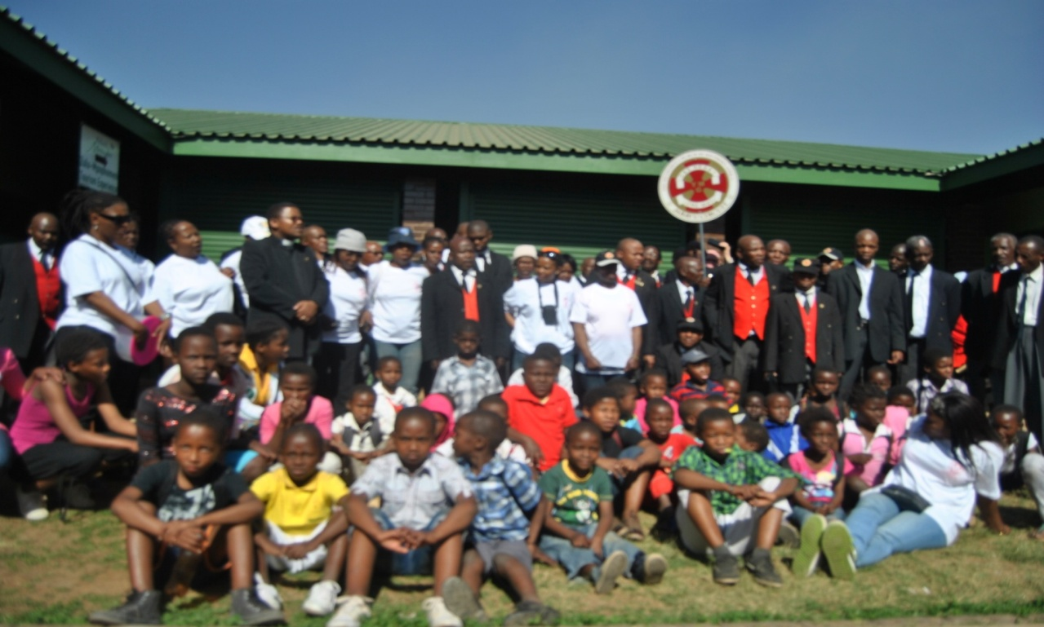
The Young Mens’ Guild visited orphans at Zenzeleni Centre and donated cloths and grocery on 2 Sept 2011.

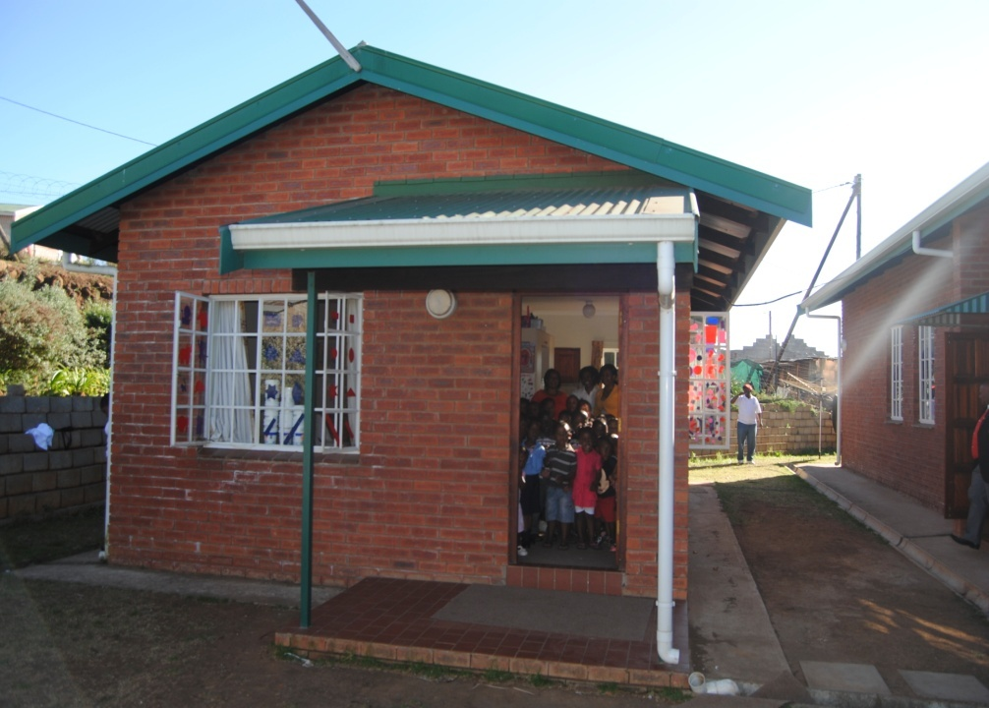
Brentwood Methodist Pre-school., has 60 children

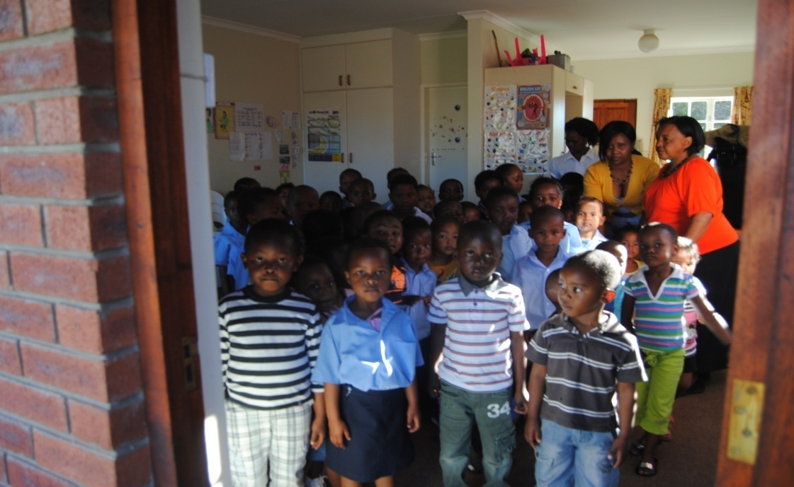
Children at Brentwood Methodist Pre-school

The important thing about this pre-School is that it looks after 60 children from the community which it provides with food, security and education whilst their parents are at work or have gone to look for work, which difficult to find. Some of the children are orphans due to the HIV pandemic. They stay with elderly grandparents. Through the pre-school we hope to give them a good childhood, a good start in education so as to reverse the vicious cycle of poverty. There are three teachers in this school who are earning very little amounts and sometimes go for months without being paid. There is also a need for money to buy food, equipments (chairs and tables) etc. Our vision is to build a pre-school building for these kids instead of them being crammed in the small caretaker’s flat and church. Any support would go a long way to helping the future of these kids to be bright.

Conclusion

From the above profile of this fascinating community in the midlands of KwaZulu-Natal, it is clear that there is a close link between the twin problems of HIV and AIDS and poverty. The lack of basic resources such as education and employment opportunities make people, especially women and children, more vulnerable to the disease. At the same time the lack of discovery, articulation and amplification of an incipient theology of HIV and AIDS (which already exists amongst the people themselves) makes it difficult for the church and other organisations to respond adequately to the challenge. Any attempts to address this problem must be accompanied by holistic initiatives of social upliftment and transformation; otherwise they will not make any real difference. That is where Brentwood Methodist Church comes in with its enthusiasm for mission and message of hope in the midst of pain and death. The one clear contribution that Brentwood Methodist Church makes, especially the church in this community, is hope—a sense of believing in a better future. As a result, although the people of Mpophomeni and Tumbleweed live in constant pain of one form or another caused by the pandemic, they hold on to the hope that the future will be different. This message is spread through our revivals, mission campaigns conducted in partnership with circuits such as Jabavu (from Soweto), the work in the pre-school children and the work with Zenzeleni which takes care of orphans where we help with providing food and cloths. The message is also spread during funeral vigils and services when we mourn those who are lost. However it is also spread during the election campaigns and services which we take part in as religious leaders in the community. We also work with councillors, community activists, traditional leader and even representative of government, in making life possible and complete for all our people. We do this because of the love of God in us. Thus they continue to survive from one day to the next. Indeed they are communities where pain meets hope, leading to life.

Bibliography

Bonnin, Deborah Rosemary. 1987. Class, Consciousness and Conflict in the Natal Midlands, 1940-1987: The Case of the B.T.R. Sarmcol Workers. Unpublished MSocSc. Thesis. University of Natal, Pietermaritzburg.
Coles, Robert. 1969. Migrants, Sharecroppers and Mountaineers. Vol. 2 of Children of Crisis. Boston: Little, Brown and Company.
Howell, Allison. 1997. The Religious Itinerary of a Ghanaian People. Ghana: Africa Christian Press.
Kumalo, Raymond Simanga. 1997. An Assessment of the Involvement of the Church with their own Members with regard to the B.T.R. Sarmcol Strike: Towards a Theology of Work. Unpublished B.Th. Honours Thesis, University of Natal, Pietermaritzburg.
———. 2003. From Deserts to Forests: A Model of Ministry and Community Development. Pretoria: C. B. Powell Bible Centre.
Little, Vance. 1991. The history of Brentwood United Methodist Church. Brentwood: JMP Productions.
Maluleke, Tinyiko S. 2002. The Challenge of HIV/AIDS for Theological Education in Africa: Towards an HIV/AIDS Sensitive Curriculum. Missionalia 2, 125-143.
Mathebe, Lucky. 2001. Bound by Tradition: The World of Thabo Mbeki. Pretoria: UNISA.
Mchunu, Frank. 2005. Interview by Author. Written transcript. March 24. Mpophomeni.
Ndlovu, Bonginkosi. 2005. Interview by Author. Written transcript. March 24. Mpophomeni.
Ngubane, Jason. 2005. Interview by Author. Written transcript. April 12. Mpophomeni.
Ntoyi, Zandile. 2005. Interview by Author. Written transcript. March 20. Mpophomeni.
Mabaso, Alzinah. 2005. Interview by Author. Written transcript. April 20. Mpophomeni.
Ngcobo, Paulinah. 2005. Interview by Author. Written transcript. March 25. Mpophomeni.
Old, Howard. 2008. Led to follow. Nashville: Abingdon Press.
Sikhakhane, Z. 2005. Interview by Author. Written transcript. April 12. Mpophomeni.
Mkhize, Kesseth. 2005. Interview by Author. Written transcript. April 12. Mpophomeni.
Philpot, Graham. 1993. Jesus is Tricky and God is Undemocratic: The Kindom of God in Amawoti. Pietermaritzburg: Cluster.
Populorum Progressio. 1967. Encyclical Letter “On the Development of Peoples.” Issued by Pope Paul VI, March 26, 1967. English trans. London: Catholic Truth Society.
Shutte, Augustine. 1994. The Ubuntu Ethic. Pietermaritzburg: Cluster Publications.
Tutu, Desmond Mpilo. 1999. No Future without Forgiveness. New York: Doubleday.
UMngeni Municipality. n.d. Social Analysis 2001 and 1996 Census Data Report.
Venter, Dawid. 1998. Researching Urban Neighbourhoods. Pretoria: IUM.

The late Rev.Dr J. Howard Olds is the former pastor of Brentwood Methodist Church. It was during his time at Brentwood that the partnership and ultimate building of Brentwood Methodist Church-South Africa was developed.
The Rev Dr Joe Peniel is a former Senior Pastor of Brentwood United Methodist Church and Professor at Vanderbilt University in Nashville Tennessee. These words are quoted from Vance Little. The history of Brentwood United Methodist Church. Brentwood: JMP, 1991), v.
Dr Sibongiseni Dlomo Provincial Minister for the Department of Health in KwaZulu-Natal. Quoted from an addressed he made during his visit to Brentwood Methodist Church on the 3rd September 2011.
Councilor Zuma of ward 12 under which Tumbleweed falls. He was speaking at a mission campaign where Brentwood Young Men’s Guild in partnership with Jabavu Methodist Church had visited Cosmos Primary School to deliver cloths and motivational talks to the students.
The uMngeni Municipality is named after the UMngeni River.
Over the decades which followed, these laws led to the forced removal of many people from their homes and familiar communities, often losing their livelihood, pride and identity.
What used to be the main building on this farm is now planned as a museum.
Mixed communities used to have whites, blacks and Indians living together as neighbors in the same area.
Today, Midmar is a large dam with an adjoining small game reserve and museum. It supplies water to Howick, Pietermaritzburg and other surrounding communities.
An integrated community is one in which two or more distinct ethnic or cultural groups live in a fairly stable relationship. Cf. the discussion by Venter (1998:14).
RDP refers to the Reconstruction and Development Programme, the socio-economic policy framework implemented by the African National Congress (ANC) Government elected in 1994. Linking economic growth, development, reconstruction, redistribution and reconciliation into a unified programme, it was later abandoned in favor of GEAR (Growth, Employment and Redistribution), a Western, monetarist-based, neo-liberal macroeconomic policy.
The African National Congress (ANC) became the ruling party in the country following the first democratic election of 1994. The Kwazulu-based Inkatha Freedom Party (IFP), which agreed to participate in the election only at the eleventh hour, was engaged in a bitter, bloody local war with the ANC, especially in KwaZulu-Natal which it governed from 1994 to 2000.
Cf. Mathebe (2001). When President Thabo Mbeki claimed that the HI-virus was linked to poverty his views were criticized both locally and internationally, being labeled as naive and unhelpful in the struggle against the disease. Mbeki seems however to have made a valid point, not least because when people are poor they are more vulnerable to contracting the HI-virus because they cannot get medication and nourishment to keep them healthy.
These estimates come from interviews with field workers at Zenzeleni and the Mpophomeni clinic.
Cf. Maluleke (2002). Tinyiko Maluleke was one of the first South African black theologians to observe the theological importance of the church with regard to HIV and AIDS
Zenzeleni is a Zulu term meaning ‘does it yourselves.’
The UDF (United Democratic Front), worked as a front for the African National Congress during its period of banning under the Apartheid regime.
Roman Catholic religious brothers were the key leaders in the establishment of Zenzeleni. Prof. Philippe Denis and Dr. Larry Kaufman were both leaders of the Roman Catholic Church in Mpophomeni, as well as members of staff respectively of the School of Religion and Theology at the University of KwaZulu-Natal and St Joseph’s Theological Institute, Cedara respectively. Together, they were instrumental in facilitating reconciliation through projects such as the building of the peace wall and the establishment of the Zenzeleni Community Centre. Other churches were involved as mediators in the B. T. R. Sarmcol strike, but afterwards were no longer visible in the building of the community.
Frank Mchunu (2005) put it this way: “We as a community were saying, ‘Now we have to start afresh and do things by ourselves without a dependency syndrome.’” As its main coordinator, Mchunu continues to play an important role in the development of the Zenzeleni Community Centre. He is also the main co-ordinator guiding the vision for a museum in Mpophomeni.

